ABOUT THE TITLE
A STUDY ON FINANCIAL GROWTH IN SBI (FY 2018-2025)
The financial growth of banks is one of the key indicators of the strength and stability of the economy. The State Bank of India (SBI), being the largest public sector bank in India, plays a significant role in mobilizing deposits, granting advances, and maintaining financial inclusion. This project focuses on studying the financial growth of SBI over the period FY 2018 to FY
2025. The analysis covers important parameters such as Total Assets, Deposits, Advances, Net Interest Income, Net Profit, and Gross NPA percentage. By examining these indicators across eight financial years, the project highlights SBI’s progress and challenges in balancing growth with asset quality. The study helps in understanding how the bank has managed to expand its business while improving profitability. It also provides insights into trends in non-performing assets, which affect the overall stability of the banking sector. This project, therefore, aims to provide a comprehensive picture of SBI’s financial growth trajectory during 2018–2025.
OBJECTIVES OF THE ST.UDY:
- To analyze how well an organization, industry, or economy is performing financially over time.
- To examine patterns in revenue, profit, investment, and expenses to understand long-term growth potential.
- To assess how internal decisions (investments, cost control) or external factors (market conditions, government policies) affect growth.
- To predict future financial performance and prepare for opportunities or challenges.
SCOPE OF THE STUDY:
The scope of this study on financial growth defines the boundaries, focus areas, and extent of analysis. It helps in understanding what the research will cover and what it will exclude.
CHAPTERIZATION:
CHAPTER-Ⅰ (INTRODUCTION)
CHAPTER-Ⅱ (DESCRIPITION OF DATA)
CHAPTER-Ⅲ (DATA ANALYSIS AND INTERPRETATION)
CHAPTER-Ⅳ (EXCEL DASHBOARD)
CHAPTER -V (CONCLUSION)

ABOUT COMPANY :
  - State Bank of India (SBI) is India’s largest public sector bank, headquartered in Mumbai, providing a wide range of banking and financial services.
  - It operates over 22,000 branches and 60,000+ ATMs worldwide, playing a key role in India’s economic and financial growth.
  - The bank offers a wide range of services including retail banking, corporate banking, wealth management, insurance, mutual funds, and digital banking solutions.
  - SBI plays a key role in India’s economic development by providing financial inclusion, credit facilities, agricultural loans, and supporting government initiatives.
  - It is also recognized as a “Fortune 500” company, reflecting its global significance.
  - With its continuous focus on modernization, customer-centric services, and digital transformation, SBI remains a cornerstone of India’s banking sector

DATASET DESCRIPTION:
The dataset represents the financial growth of the State Bank of India (SBI) from FY 2018 to FY 2025. It contains annual values of key financial indicators that highlight the bank’s performance and growth trends.

Rows: 8 (Financial years: 2018–2025)
Columns: 7 (Financial variables)

Variables in the Dataset:
  - Year – Financial Year (2018 to 2025).
  - Total Assets (₹ Crore) – Represents the total value of assets held by SBI.
  - Advances (₹ Crore) – Total loans and advances given by the bank to customers.
  - Deposits Income (₹ Crore) – Total customer deposits collected by the bank.
  - Net Interest Income (₹ Crore) – Income earned from interest on loans minus interest paid on deposits.
  - Net Profit (₹ Crore) – Annual profit of SBI after all expenses and provisions.
  - Gross NPA (%) – Percentage of total loans classified as Non-Performing Assets (NPA).
Year | Total Assests (₹  Crore) | Advances (₹  Crore) | Deposits Income  (₹ Crore) | Interest Income  (₹ Crore) | Net Profit (₹  Crore) | Gross  NPA%
2018 | 36,80,914 | 21,85,877 | 29,11,386 | 88,349 | 862 | 5.00%
2019 | 38,48,680 | 22,71,735 | 29,06,343 | 88,981 | 8,629 | 3.72%
2020 | 42,51,515 | 23,72,434 | 31,11,817 | 98,084 | 14,488 | 2.83%
2021 | 45,34,430 | 24,49,498 | 36,81,277 | 1,10,710 | 20,410 | 4.98%
2022 | 49,87,597 | 27,33,967 | 40,50,534 | 1,20,708 | 31,676 | 3.97%
2023 | 55,16,979 | 31,99,269 | 44,23,778 | 1,44,841 | 50,232 | 2.78%
2024 | 61,79,694 | 37,03,971 | 49,16,077 | 1,59,876 | 61,077 | 2.24%
2025 | 66,76,053 | 41,63,312 | 53,82,190 | 1,66,965 | 70,901

Study of financial growth in SBI

DATA ANALYSIS AND INTERPERTATION:
The collected data was analyzed using Excel. Pivot Tables and Charts were created for each questions.
- How have SBI’s Total Assets grown from FY2018 to FY2025?
Row Labels | Sum of Total Assests  (₹ Crore)
2018 | 3,680,914
2019 | 3,848,680
2020 | 4,251,515
2021 | 4,534,430
2022 | 4,987,597
2023 | 5,516,979
2024 | 6,179,694
2025 | 6,676,053
Grand  Total | 39,675,862

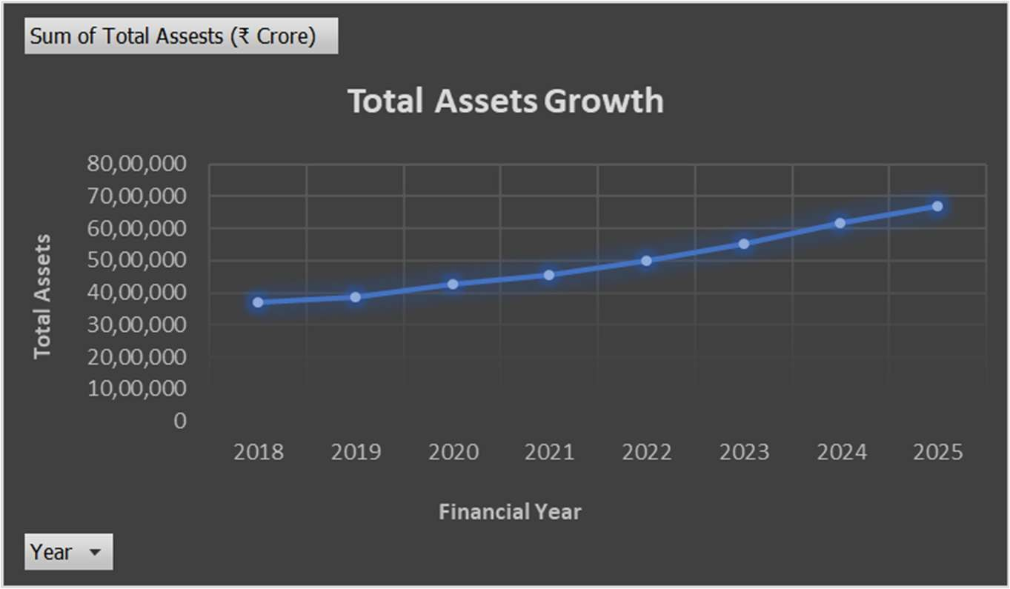

INTERPRETATION: SBI’s Total Assets have shown a steady and strong upward trend from FY2018-19 to FY2024-25. The bank’s asset base rose from around ₹36.6 lakh crore in FY201819 to nearly ₹66.8 lakh crore in FY2024-25, almost doubling within seven years.

- What is the trend in SBI’s Advances (Loans) compared to Deposits across FY2018–2025?
Row Labels | Sum of Advances (₹ Crore) | Sum of Deposits Income (₹ Crore)
2018 | 21,85,877 | 29,11,386
2019 | 22,71,735 | 29,06,343
2020 | 23,72,434 | 31,11,817
2021 | 24,49,498 | 36,81,277
2022 | 27,33,967 | 40,50,534
2023 | 31,99,269 | 44,23,778
2024 | 37,03,971 | 49,16,077
2025 | 41,63,312 | 53,82,190
Grand Total | 2,30,80,063 | 3,13,83,402

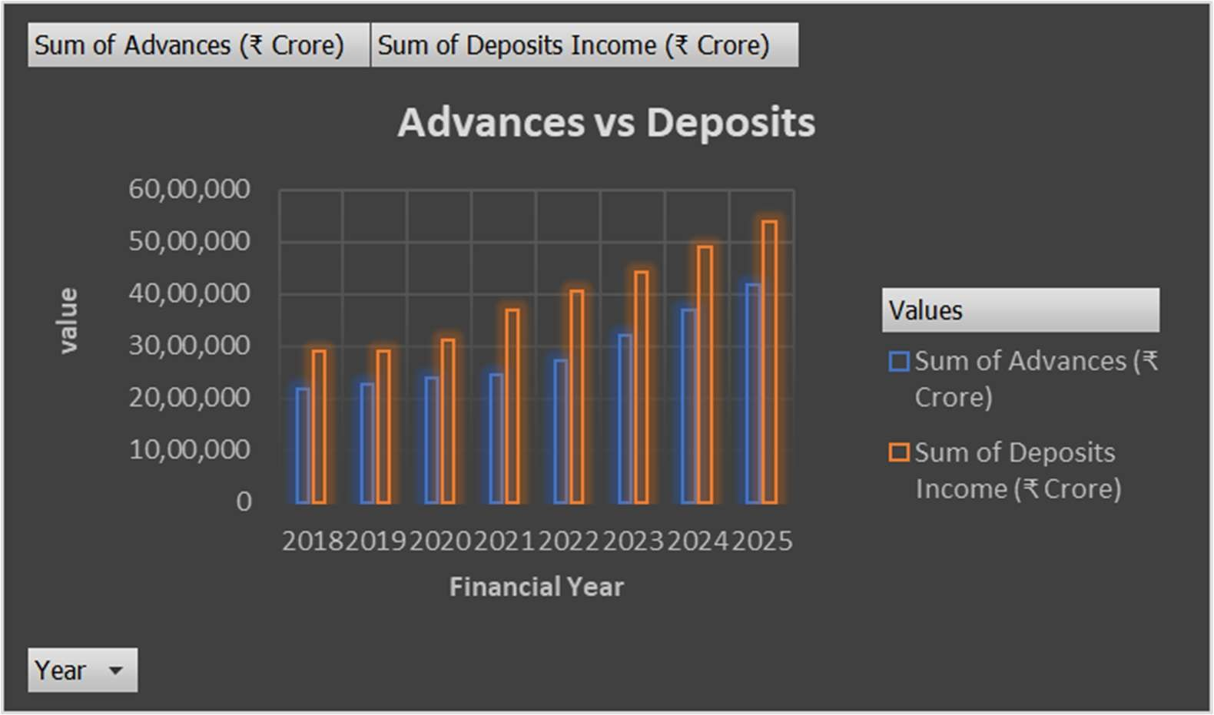

INTERPETATION: SBI’s Deposits and Advances have both shown steady growth from FY2018-19 to FY2024-25, forming the backbone of the bank’s financial strength.
  - Strong customer trust and deposit mobilization.
  - Balanced growth between liabilities and assets.

  - How has SBI’s Net Profit changed over the years (2018–2025)?
Row Labels Sum of Net Profit (₹ Crore)
2018 862 2019 8629 2020 14488
- 20410
- 31676
- 50232
- 61077
- 70901
Grand Total 258275
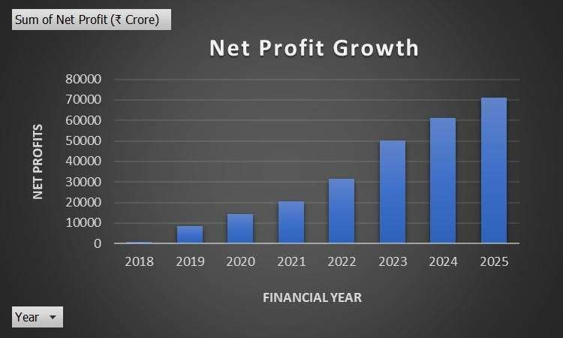
INTERPRETATION: SBI’s Net Profit has grown consistently year-on-year, with the sharpest rise between FY202122 and FY2022-23. This steady upward trend highlights improved profitability, asset quality, and operational efficiency.

  - What is the trend in Net Interest Income (NII) from FY2018–2025?
Row Labels | Sum of Interest  Income (₹ Crore)
2018 | 88,349
2019 | 88,981
2020 | 98,084
2021 | 110,710
2022 | 120,708
2023 | 144,841
2024 | 159,876
2025 | 166,965
Grand  Total | 978,514

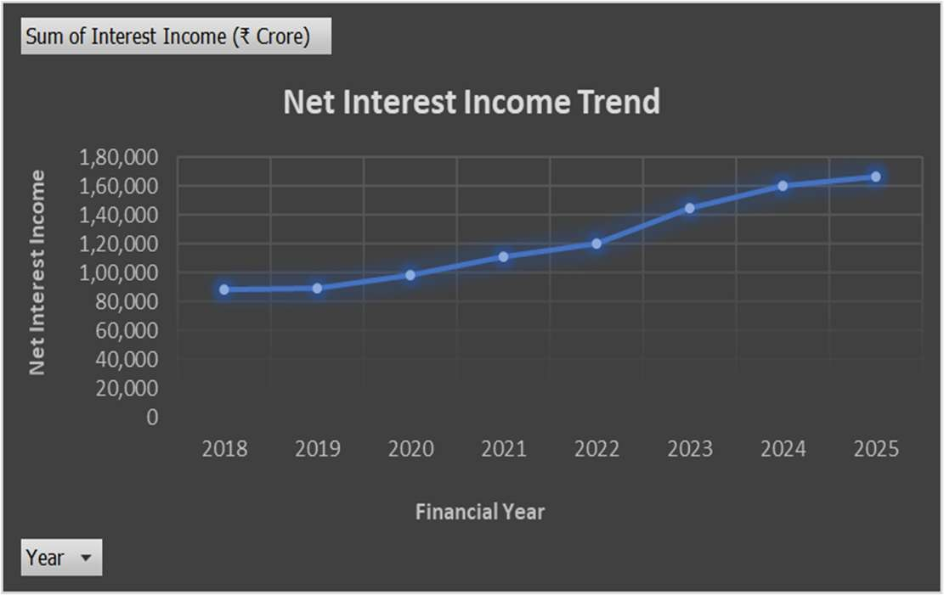
INTERPRETATION: SBI’s Net Interest Income has shown steady YoY percentage growth, with the strongest rise during the post-pandemic years. This trend reflects robust lending activity and improved interest margins.
Although the growth rate varied across years, the overall trend shows a sustained rise in NII, indicating SBI’s strong lending operations and stable interest earnings.

  - What is the movement of Gross NPA % across FY2018–2025?

Row Labels | Sum of Gross  NPA%
2018 | 0.05
2019 | 0.0372
2020 | 0.0283
2021 | 0.0498
2022 | 0.0397
2023 | 0.0278
2024  2025 | 0.0224
Grand  Total | 0.2552

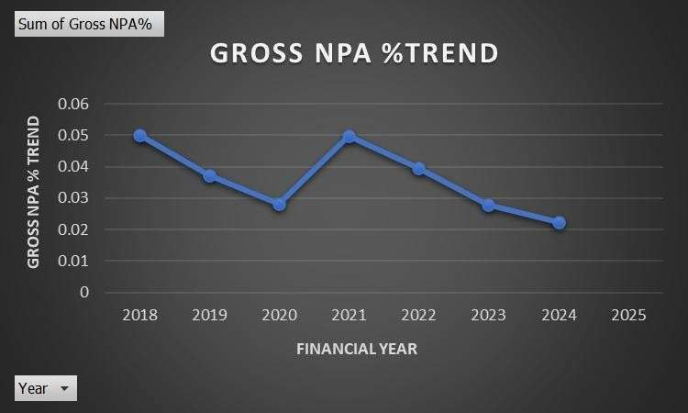

INTERPETATION: SBI recorded its steepest decline in Gross NPA % during the years following FY2018-19, when NPAs stood at relatively higher levels.
This decline indicates that SBI was able to strengthen its asset quality and reduce the burden of bad loans.
Overall, the steep fall in Gross NPA % highlights SBI’s improving financial health, risk management efficiency, and stronger profitability outlook.

EXCEL DASHBOARD:

SBI FINANCIAL PERFORMANCE DASHBOARD
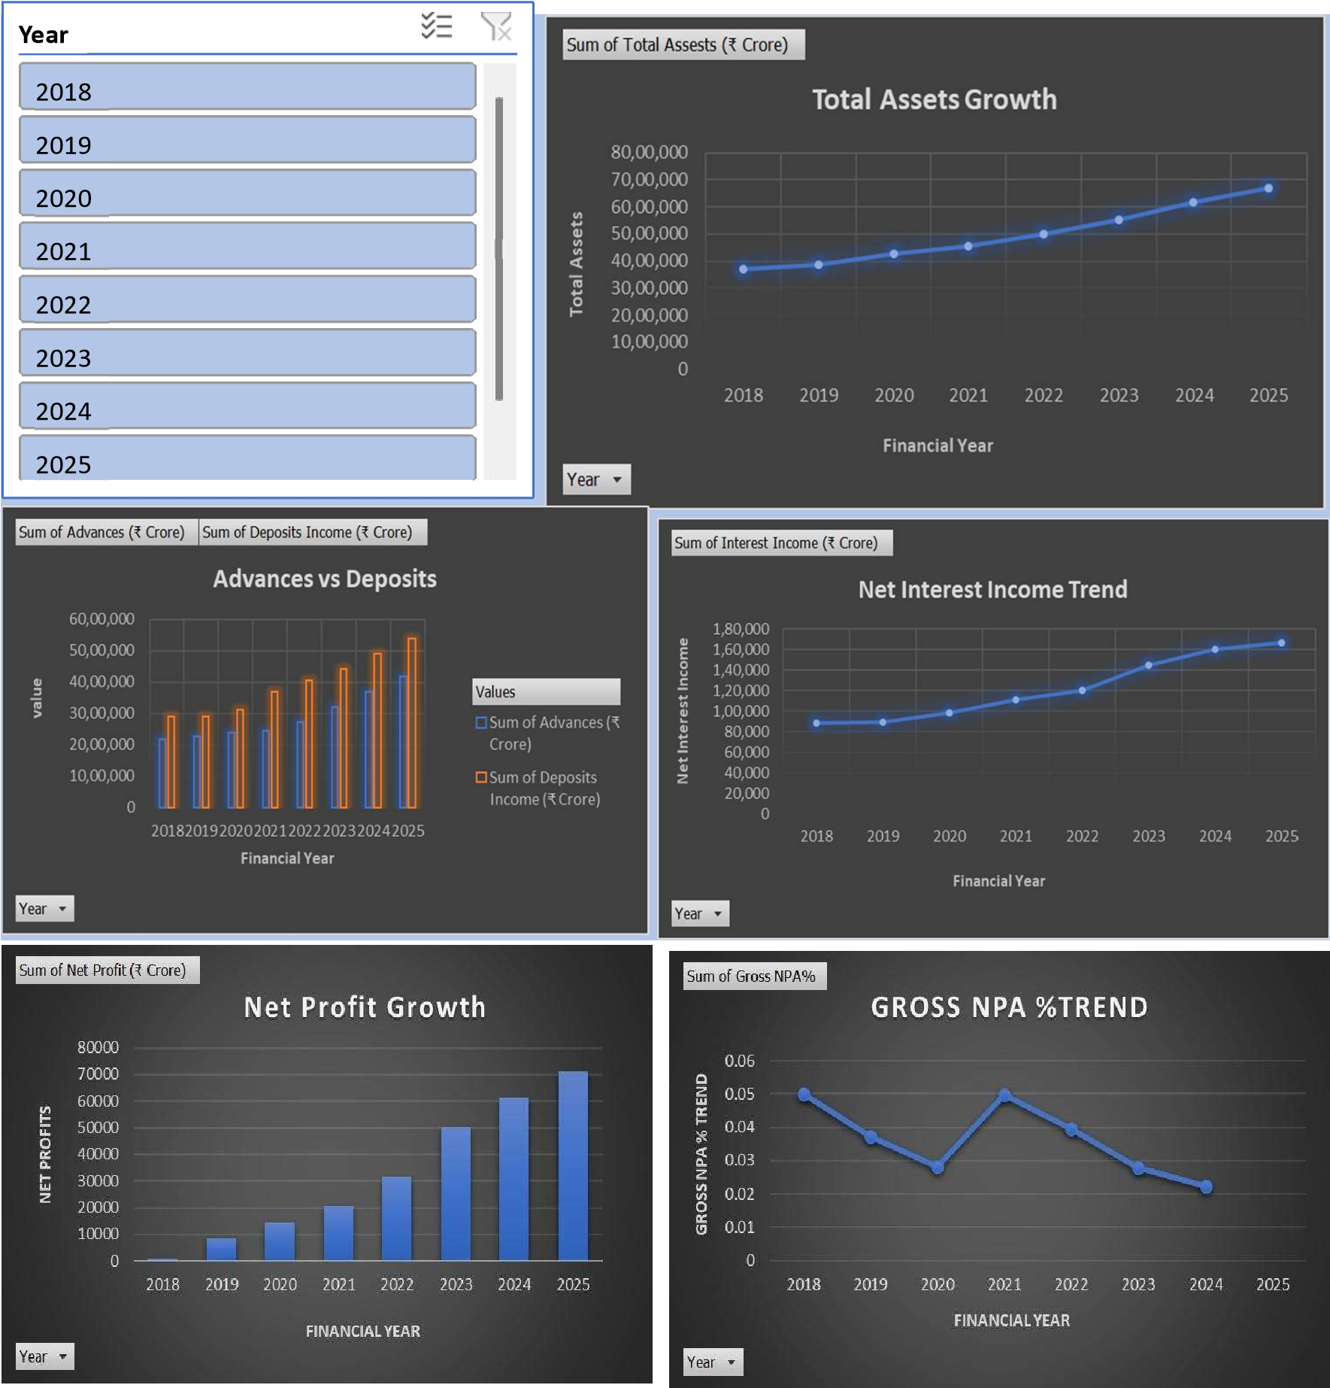

PROCEDURE OF DASBHBOARD:
  - Enter the SBI financial dataset (2018–2025) into Excel in a structured table format. Columns included: Year, Total Assets, Advances, Deposits, Net Interest Income, Net Profit, Gross NPA %.

  - Select the dataset → Go to Insert → Pivot Table.

  - Create 5 different Pivot Tables, one for each key analysis:

  - Year vs Total Assets

  - Year vs Advances and Deposits

  - Year vs Net Interest Income

  - Year vs Net Profit

  - Year vs Gross NPA %

  - From each Pivot Table, insert the appropriate chart:

  - Line Chart → Total Assets Growth

  - Clustered Column Chart → Advances vs Deposits

  - Line Chart → Net Interest Income Trend

  - Column Chart → Net Profit Growth

  - Line Chart → Gross NPA % Trend

  - Add tles to each chart (e.g., Total Assets Growth, Net Profit Growth).

  - Remove unnecessary field buttons to make charts neat.

  - Apply consistent colors and dark background for professional look.

  - Add Slicers

  - Insert a slicer for Year (right-click Pivot Table → Insert Slicer → Year).

  - Connect the slicer to all Pivot Tables so that all charts update simultaneously.

  - Arrange Dashboard

  - Create a new worksheet named Dashboard.

  - Place all 5 charts neatly in a grid format (top: Assets Growth, Advances vs Deposits; middle: NII, Net Profit; bottom: Gross NPA %).

  - Place the slicer on the left for easy filtering.

  - Final Touch

  - Add a heading: “SBI FINANCIAL PERFORMANCE DASHBOARD”.

  - Adjust chart sizes to fit on an A4 sheet (Landscape orientation) for printing.

  - Save the file.

CONCLUSION:
The study of SBI’s financial growth from FY 2018 to FY 2025 highlights consistent improvement in the bank’s performance. Total Assets, Deposits, and Advances showed steady year-on-year growth, reflecting SBI’s expanding customer base and strong financial stability. Net Interest Income and Net Profit witnessed significant growth, particularly after FY 2020, indicating improved profitability and efficient operations. Gross NPA % showed a declining trend after FY 2021, reflecting better asset quality and effective risk management. Overall, SBI has strengthened its financial position, balancing growth with improved profitability and asset management.

SUGGESTIONS

  - Continue reducing Gross NPAs through better credit monitoring and recovery mechanisms.

  - Enhance digital banking and technological innovation to attract more customers.

  - Introduce new customer-centric deposit and loan schemes to increase financial inclusion.

  - Focus on cost optimization and operational efficiency to sustain profitability growth.

  - Expand international presence to diversify revenue sources and reduce dependence on domestic operations.

REFERENCES

  - State Bank of India Annual Reports (2018–2025).

  - Dataset: SBI Financial Growth FY2018–2025 (provided for analysis).

  - Microsoft Excel (2021/365) – Data Analysis and Dashboard Preparation.

  - Books and academic resources on Financial Management and Banking Performance Analysis.

